**Module 4 – TDD using JUnit5 and Mockito**

**Exercise 1: Mocking and Stubbing**

|  |  |
| --- | --- |
| ExternalApi.java  package com.example;  public interface ExternalApi {  String getData();  } | MyService.java  package com.example;  public class MyService {      private ExternalApi api;      public MyService(ExternalApi api) {          this.api = api;      }      public String fetchData() {          return api.getData();      }  } |

|  |
| --- |
| MyServiceTest.java  package com.example;  import static org.junit.jupiter.api.Assertions.assertEquals;  import org.junit.jupiter.api.Test;  import static org.mockito.Mockito.mock;  import static org.mockito.Mockito.when;  public class MyServiceTest {      @Test      public void testExternalApi() {          ExternalApi mockApi = mock(ExternalApi.class);  when(mockApi.getData()).thenReturn("Mock Data");  MyService service = new MyService(mockApi);  String result = service.fetchData();          assertEquals("Mock Data", result);      }  } |

**OUTPUT:**

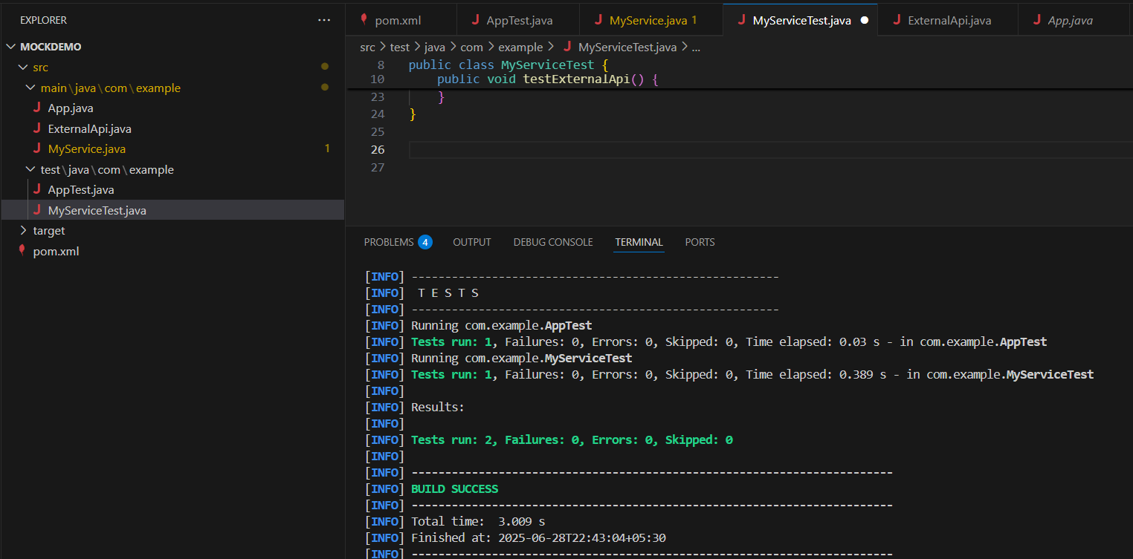

**Exercise 2: Verifying Interactions**

|  |  |
| --- | --- |
| ExternalApi.java  package com.example;  public interface ExternalApi {  String getData();  } | MyService.java  package com.example;  public class MyService {      private ExternalApi api;      public MyService(ExternalApi api) {          this.api = api;      }      public String fetchData() {          return api.getData();      }  } |

|  |
| --- |
| MyServiceTest.java  package com.example;  import org.junit.jupiter.api.Test;  import static org.mockito.Mockito.mock;  import static org.mockito.Mockito.verify;  public class MyServiceTest {      @Test      public void testVerifyInteraction() {  ExternalApi mockApi = mock(ExternalApi.class);  MyService service = new MyService(mockApi);          service.fetchData();  verify(mockApi).getData();      }  } |

**OUTPUT:**

